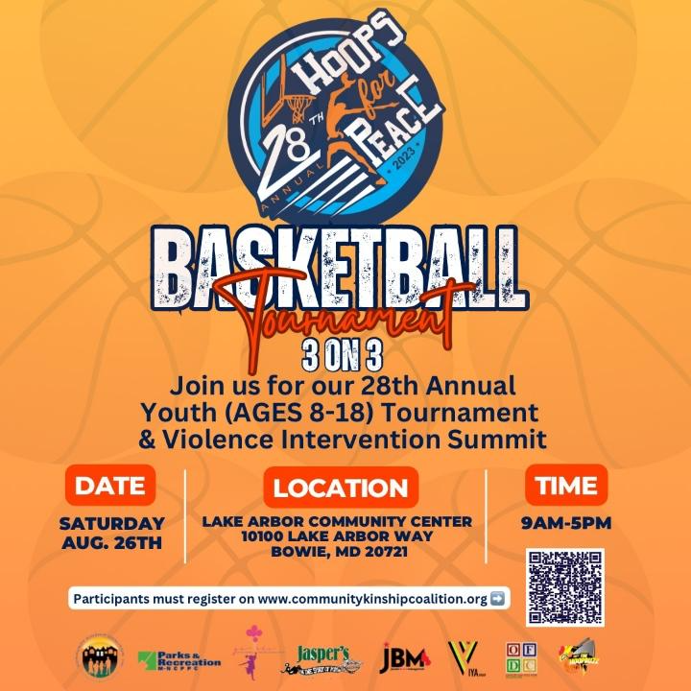
Violence Intervention Youth Summit
Vendor Agreement
2023

Event: 28th Annual “Hoops 4 Peace” Violence Intervention Youth Summit
Date: Saturday, August 26, 2023
Cost: $75.00

Please complete the enclosed application for processing

Event/Program/Activity: 28th Annual Hoops 4 Peace Violence Intervention Youth Summit Date: Saturday, August 26, 2023

Vendor Information

Business/Organization Name:

Contact Name: _________________________________________ Title:

Business Address:

City: State: Zip Code:
Phone: _____________________ Cell: Fax:

E-mail:_________________________________________________

Social Media: Facebook: _______________________________________ Twitter:

Please Circle one: I am an: Outside Vendor Non-Profit Organization

Description of Merchandise/Service to be sold (or info on non-profit):

Average price range of your merchandise/service: ___________________

Are you interested in sponsoring an outside activity or donating merchandise for CKC’s other events? Yes No

Donation Instructions: Please send your check or money order made out to:

Community Kinship Coalition Inc.
10114 Campus Way South, Suite 304
Largo, Maryland 20774

Contact: Please direct any questions to George Hodge at kinship2004@gmail.com

Vendor Agreement

In consideration of the opportunity to offer or display its products and/or services at a CKC Event. Vendor/Exhibitor agrees as follow:

- Vending and exhibition at a CKC event is a privilege and must be conducted in a professional manner. Any form of harassment or inappropriate behavior on the part of the vendor/exhibitor toward members of the CKC Event will result in immediate removal from the event and permanent removal of privileges without refund.

- All or Vendors/Exhibitor’s agents, employees, or representatives are expected to present a professional image, and their goods and/or services should be aesthetically pleasing, clean and of an orderly appearance. Vendor’s/Exhibitor’s goods or services shall not consist of any materials prohibited by CKC, which presently include (a) sales of drug-related images or paraphernalia, (b) the solicitation of books, food, or any other items that may pose a conflict of interest with contracted services that have exclusive agreements with CKC, (c) the solicitation of credit card applications, and (d) any activities that may result in the revocation of otherwise endanger CKC’s tax-exempt status, The categories of prohibited materials may be amended from time to time.

- All sales and shall take place in the Lake Arbor Community Center Vendors/Exhibitors are not allowed to block the pathways in these areas or any
points of ingress or egress.

- Any damage to the Lake Arbor Community Center/Grounds/property caused by Vendors will be billed directly to vendor/exhibitor and will result in possible no vendor privileges.

- Waiver and Release of Liability. Vendor/Exhibitor, for itself, its employee, representatives, agents and assigns, hereby release, waives, discharges, and covenants not to sue CKC, its Board Members, Trustees, officers, agents, employees, contractors, participants, volunteers, and representatives from liability for any and all claims arising from loss of property and illness or injury, including death, that may result from any and all of its activities of CKC , whether or not caused by the negligence of CKC, its Board Members, Trustees, officers, agents, employees, contractors, participants, volunteers or otherwise. Initials:

- Vendor/Exhibitor agrees to defend, indemnify, and hold harmless CKC, its Board Members, Trustees, officers, agents, employees, contractors, participants, volunteers from and against all liability, claims, and demands, on account of injury, loss, damage, or expense, including defense costs, court costs, and attorney’s fee, which arise out of or are in any manner connected with this Agreement and due or claimed to be due to the negligence of vendor/exhibitor, its agents, employees, or representatives.

- Insurance: YES NO If, yes then complete and include the attached Exhibit A of Vendor/Exhibitor’s Insurance Requirements
- Non-Waiver: Waiver by either party or any provision of this Agreement or warranty of representation herein shall not constitute a waiver of any subsequent breach of the same or any other provision.
- Entire Agreement: This Agreement contains the entire Agreement between the parties and supersedes all prior written or oral agreements with respect to the subject matter herein. This Agreement may be amended or modified only by mutual written consent of the authorized representatives of both parties.
- Applicable Law: This Agreement shall be governed in all respects by the laws of the State of Maryland. Venue for any action to enforce the terms and conditions of this Agreement shall be Prince George’s County, Maryland.
- Vendor/Exhibitor may not assign, transfer, convey, or encumber any of its rights under this Agreement, directly or indirectly, without prior written approval of CKC.
- Neither party will incur any liability to the other if its performance of any obligation under this Agreement is prevented or delayed by causes beyond its control and without the fault or negligence of either party. Causes beyond a party’s control may include, but are not limited to, acts of God or war, changes in controlling law. Regulations, orders or the requirements of any governmental entity, severe weather conditions, civil disorders, natural disasters, fire, epidemics and quarantines, litigation, general strikes throughout the trade, and freight embargoes.

This Agreement may be executed in one or more counterparts, each which shall constitute one and the same agreement. Further, the parties may execute the Agreement via fax, electronic mail transmission. A true copy and correct copy of the Agreement, as executed by the parties, may be used in lieu of an original for all purposes permitted by law.

This Agreement is made on this (day) of August (Month) 2023 (year) between Community Kinship Coalition Inc. and Vendor/Exhibitor:

By

Dated: By Dated:

Vendor Schedule
ACTIVITY | DESCRIPTION | START | FINISH
Arrival/Set-Up | Check In | 8:00am
Opening Ceremony | Set up | 9:00am
Circle of Peace | Opening ceremony-Gymnasium | 9:30am
 | Open to Public | 9:30am
Breakdown | Breakdown | 4:00pm

Registration:
Please complete the enclosed application for the sale and return it by August 21, 2023.
Application will be reviewed for entry into the event and confirmation will be communicated as soon as you have been approved. It is advised that you turn in application as early as possible to help secure your spot in the event.

Registration Fee: All Vendors are encouraged to make a contribution to the event.

Space: One rectangular table (2-4 chairs) located in the Lake Arbor Community Center.

Check in:
There will be ONE check-in area which every vendor will be expected to visit upon arrival at the site. Please do not go to the vendor area without checking in first. Upon arrival, you will be directed to set up area, where you can unload your supplies. As we have many people to unload in a very short time, you will be asked to unload very quickly and then move your car immediately.

Set up will begin at 8:00 AM, with the expectation that all vendor booths will be ready by 9:30AM. You will be allowed access to the site before that time if necessary (earliest 8:00am)
Parking: You will be directed to free parking in a designated Vendor parking area.

booth assignments:
Booth space numbers\assignments are given at check in. You may bring whatever type of display materials that you like as long as they fit within your space. Please be considerate of your neighboring vendors and stay within your allotted booth space.

Extra table and chairs:
Unless you ordered extra tables and\or chairs prior to day of event, none will be available. Do not take them from other areas.

Breakdown:
The event begins approximately at 9:00am, although it really takes off once the participant’s reports to workshops around 10:00 pm. The event ends at approx. 5:00 pm. Please DO NOT break down before 4:00 pm. ALL VENDORS MUST BE BROKEN DOWN BY 4:30 pm – NO EXCEPTIONS.

Trash:
Vendors are responsible for cleaning up the trash in their booth. Do not leave flyers, newspapers or any other samples or materials at your booth when you leave.
WEATHER: Hoops for Peace is a rain or shine event. There is no rain date.
VOLUNTEERS:
We are always fortunate with the people who come forward each year to help out, but we could always use more! If you or anyone you know is interested in volunteering for a couple of hours, please submit a volunteer form.

